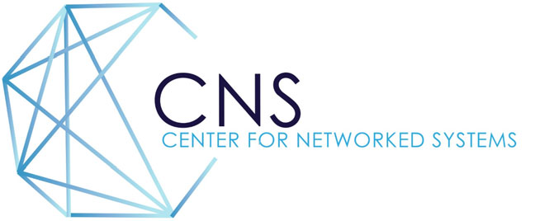

CNS 2022 Research Review Agenda
Friday, April 29, 2022

9:00 a.m. Welcome
George Porter and Stefan Savage, CNS Co‐Directors and CSE Professors

9:15 a.m. Session 1
Trackers Bounce Back: Measuring Evasion of Partitioned Storage in the Wild (15 min + 5 min Q&A)
Audrey Randall, CSE Graduate Student (Advisors: Aaron Schulman, Geoff Voelker, and Stefan Savage)
FaaSnap: FaaS Made Fast Using Snapshot-based VMs (15 min + 5 min Q&A)
Lixiang Ao, CSE Graduate Student (Advisors: Geoff Voelker and George Porter)
Forward Pass: On the Security Implications of Email Forwarding Mechanism and Policy (15 min + 5 min Q&A)
Enze “Alex” Liu, CSE Graduate Student (Advisors: Stefan Savage and Geoff Voelker)

10:15 a.m. 5-Minute Break
10:20 a.m. Keynote Speaker
SkySafe: The Challenges of Tracking Every Drone in Every Place
SkySafe founder and CEO, Grant Jordan (UC San Diego CSE Alumnus).
What started as a seemingly simple project to stop malicious drones, has evolved into a massive
multi-million dollar (and multi-PhD) effort to understand and track thousands of drone flights in critical
airspace. We'll talk about what it takes to build systems and infrastructure to simultaneously allow the
use of drones for good, while keeping out the careless, clueless, and criminal elements.

10:50 a.m. Session 2
Junkyard Datacenters: Carbon-efficient Computing Systems from Old Phones (15 min + 5 min Q&A)
Jennifer Switzer, CSE Graduate Student (Advisors: Pat Pannuto and Ryan Kastner)
Federated Infrastructure: Usage, Patterns, and Insights from "The People's Network" (15 min + 5 min Q&A)
Alex Yen, CSE Graduate Student (Advisor: Pat Pannuto)
Corundum: An Open-Source Framework for In-Network Compute (15 min + 5 min Q&A)
Alex Forencich, ECE Postdoctoral Researcher (Advisors: George Papen and George Porter)

11:50 a.m. 5-Minute Break

11:55 a.m. Lightning Talks
Continuous 2‐minute (live) lightning presentations by 12 graduate students.

12:25 p.m. Concluding Remarks and Feedback from Company Representatives

